**Daikibo Factory down time analysis using Tableau**

**Objective**:

Daikibo collects telemetry data from 9 machine types across 4 factories every 10 minutes. This data is used to find the factory downtime and the machines causing it.

**Data Overview:**

Source : JSON

Scope: One month (May 2021) telemetry data, 4 factories, 9 machine types and 10 minutes interval.

Factory details:

* Daikibo Factory Meiyo (Tokyo, Japan)
* Daikibo Factory Seiko (Osaka, Japan)
* Daikibo Berlin (Berlin, Germany)
* Daikibo Shenzhen (Shenzhen, China)

Machine types:

CNC, Conveyor belt, Furnace, Heavy Duty drill, Laser cutter, Laser Welder, Metal press, Spot Welder, Air Wrench.

**Findings:**

Factory-level Downtime :

Daikibo Factory Seiko (Osaka, Japan) recorded the highest downtime compared to Meiyo, Berlin, and Shenzhen. Below is the bar chart showing total downtime in minutes for each factory.

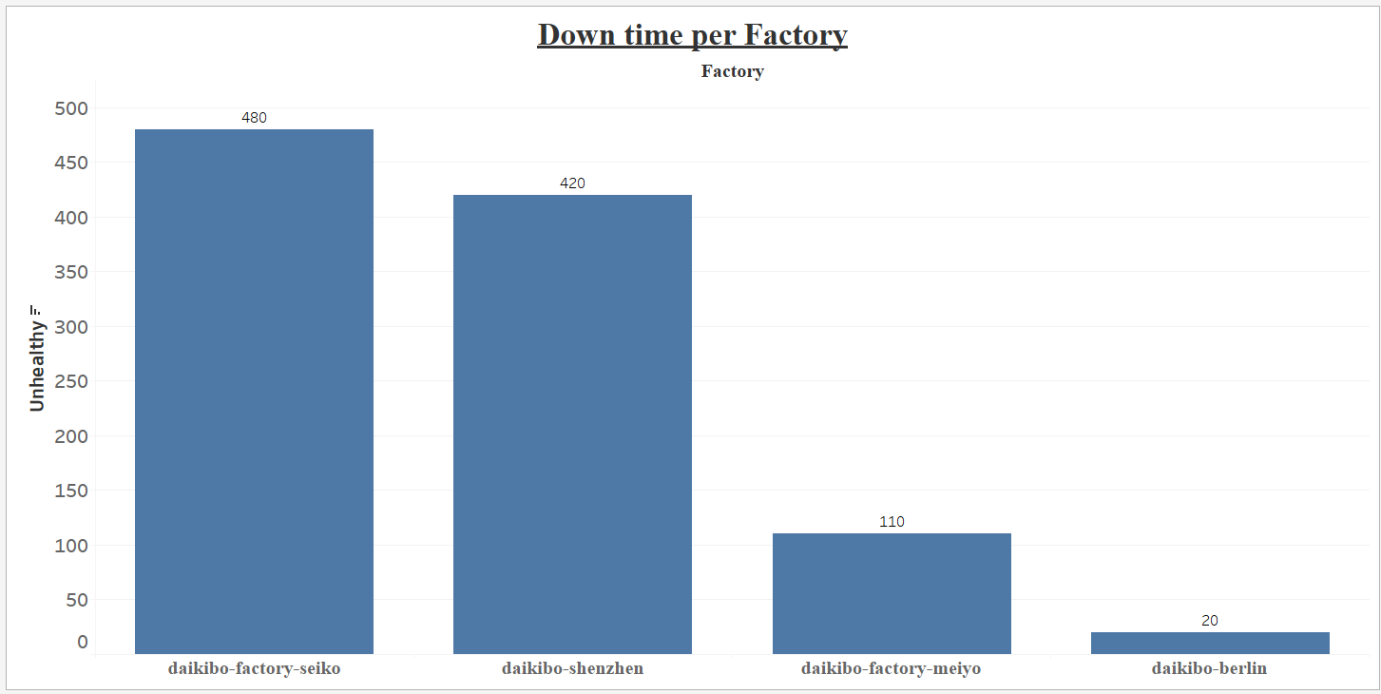

Machine-level Downtime:

Laser Welder had the most unhealthy events and contributed the highest downtime. Below is the bar chart showing total downtime in minutes for each machines.

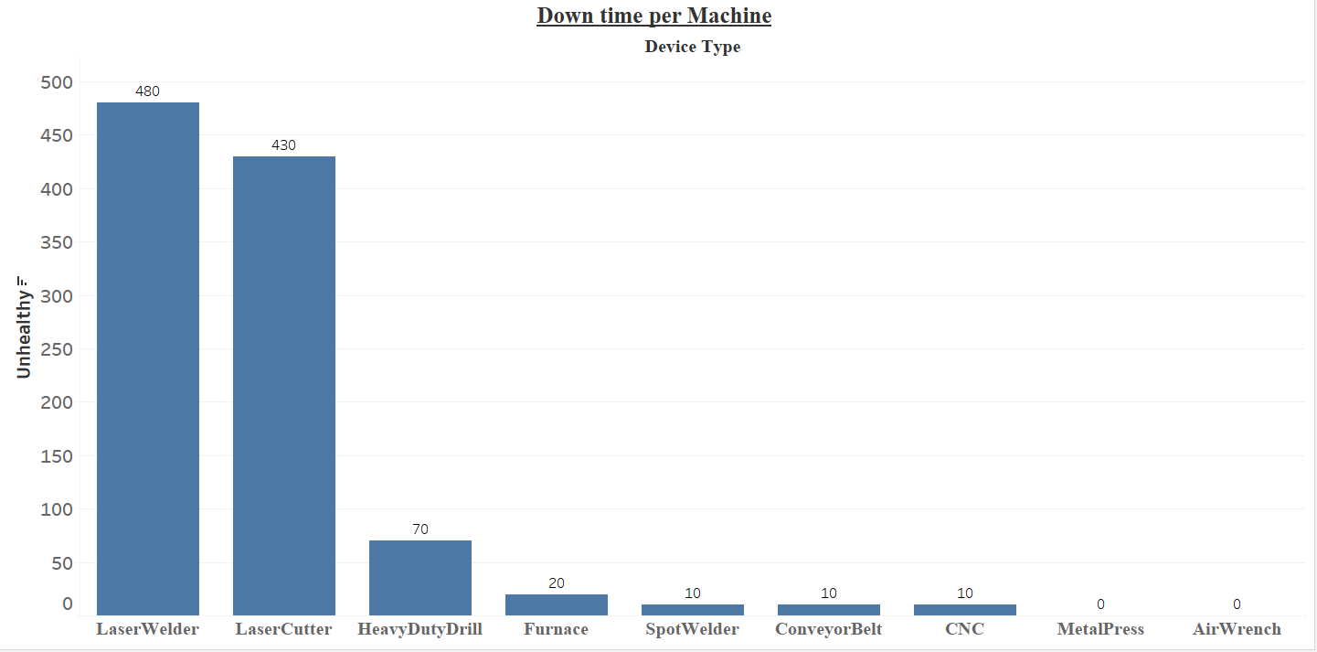

Below chart shows the % total downtime in minutes for each machines across factories.

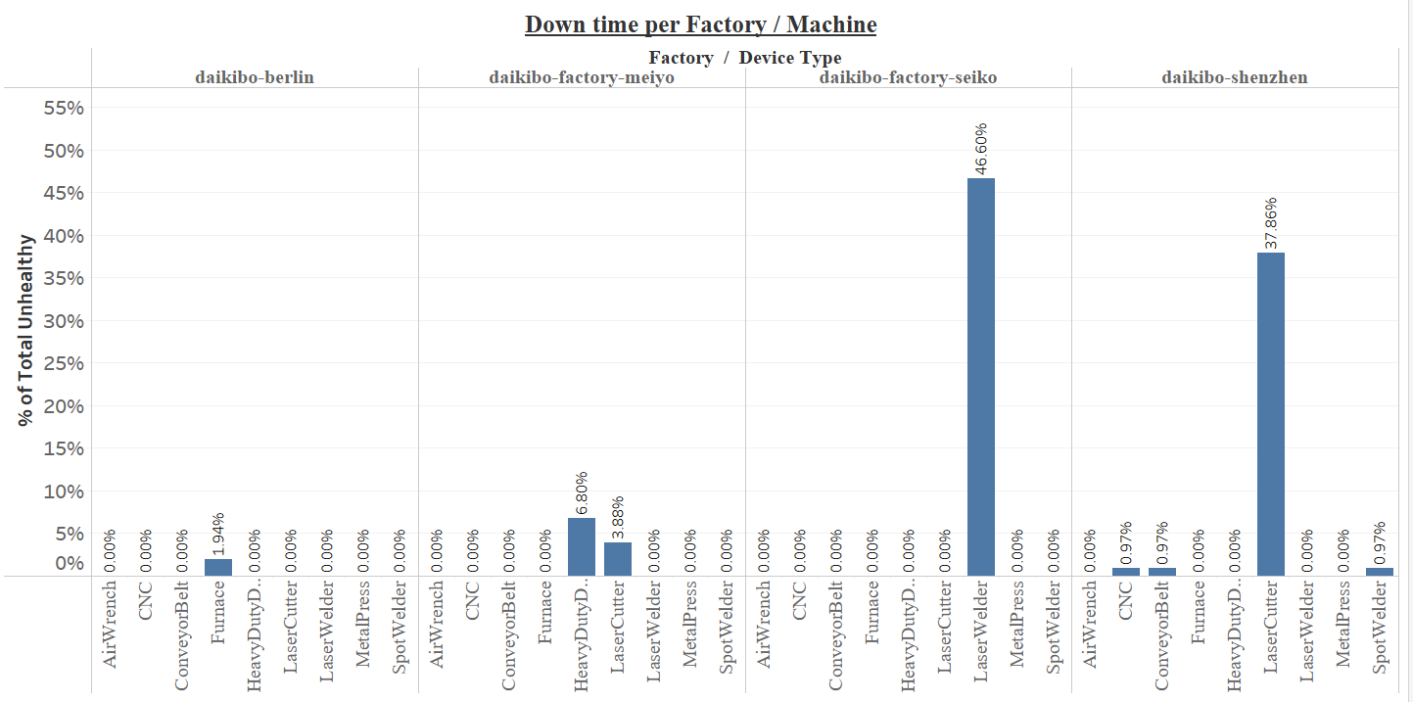

**Key Insights:**

* Laser Welder at Seiko factory contributed 46.6% of total Daikibo factory downtime.
* Laser Cutter at Shenzhen factory contributed 37.86% and at Meiyo factory 3.88% of total downtime.
* Air Wrench and Metal press were the healthiest machines across the factories without any downtime.